Session 1

1. Create an Array of Employee class and initialize array elements with different employee objects.
2. Create a class Beverages, the Tea and Coffee sub classes are using the common method addMilk and they are implementing abstract method void addIngredient.

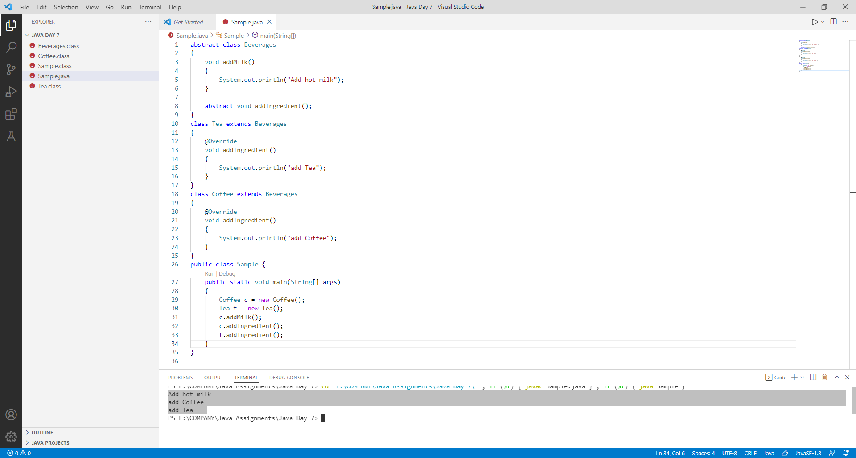

**Session 2**

1. Implementing Accessibility of members across packages and classes

**Public function in same class:**

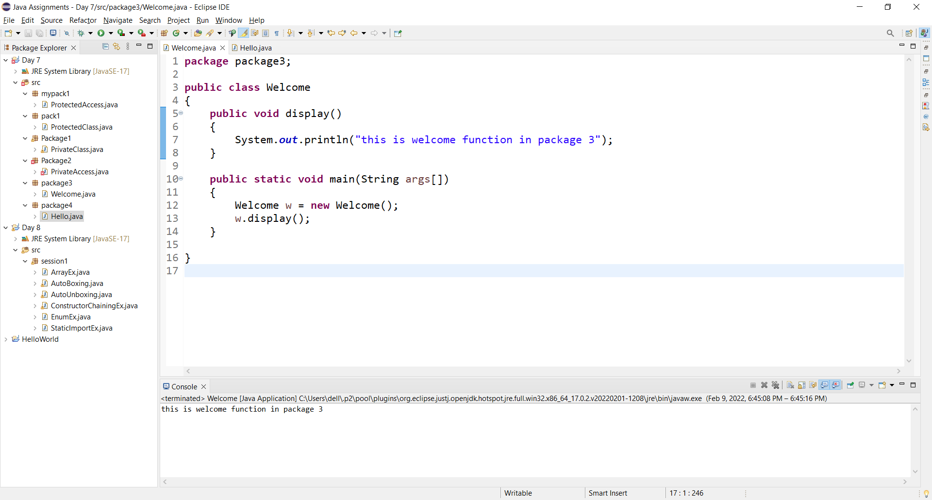

**Public access modifier use in Different package subclass:**

Welcome Class

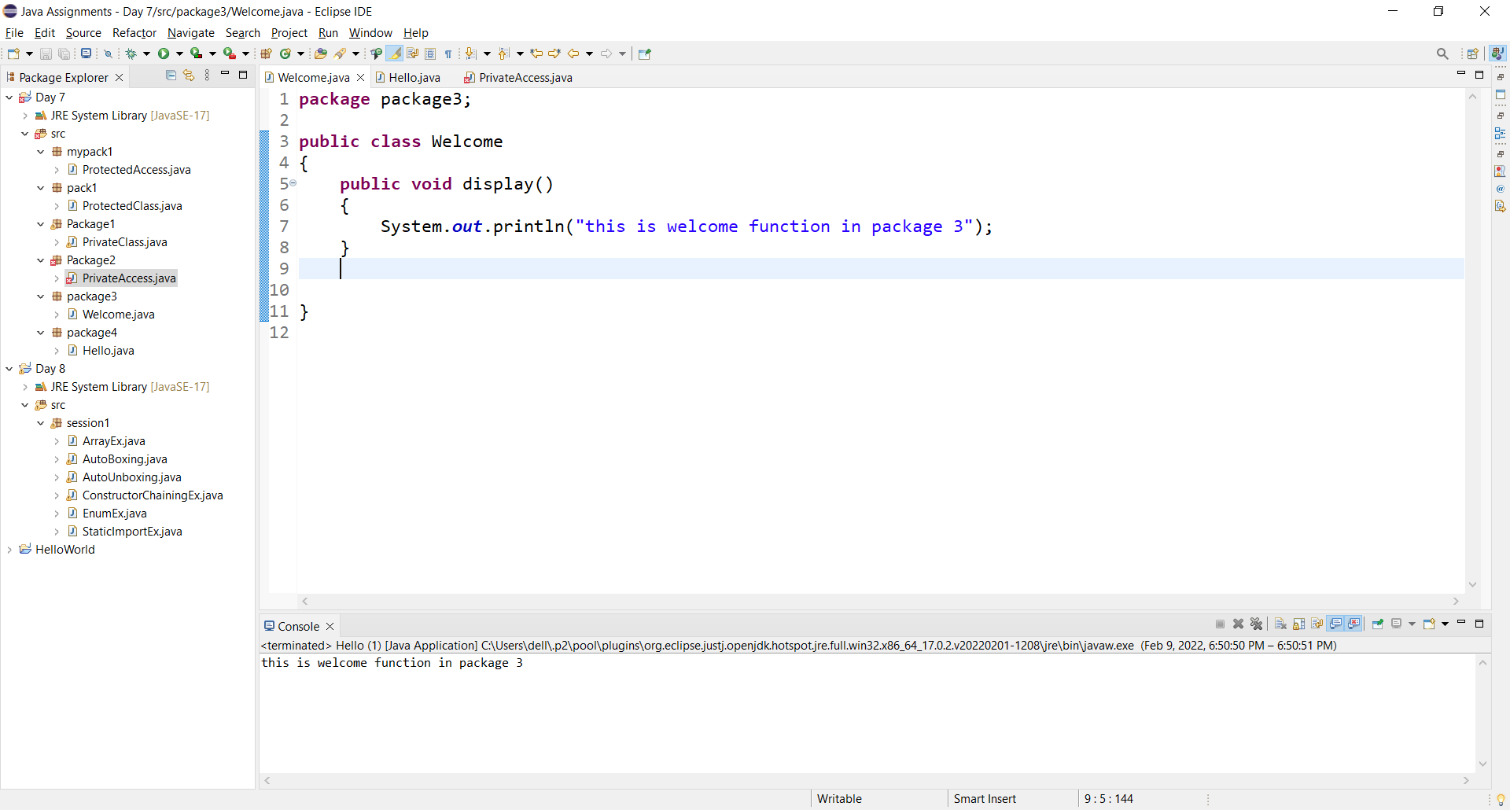

Hello class

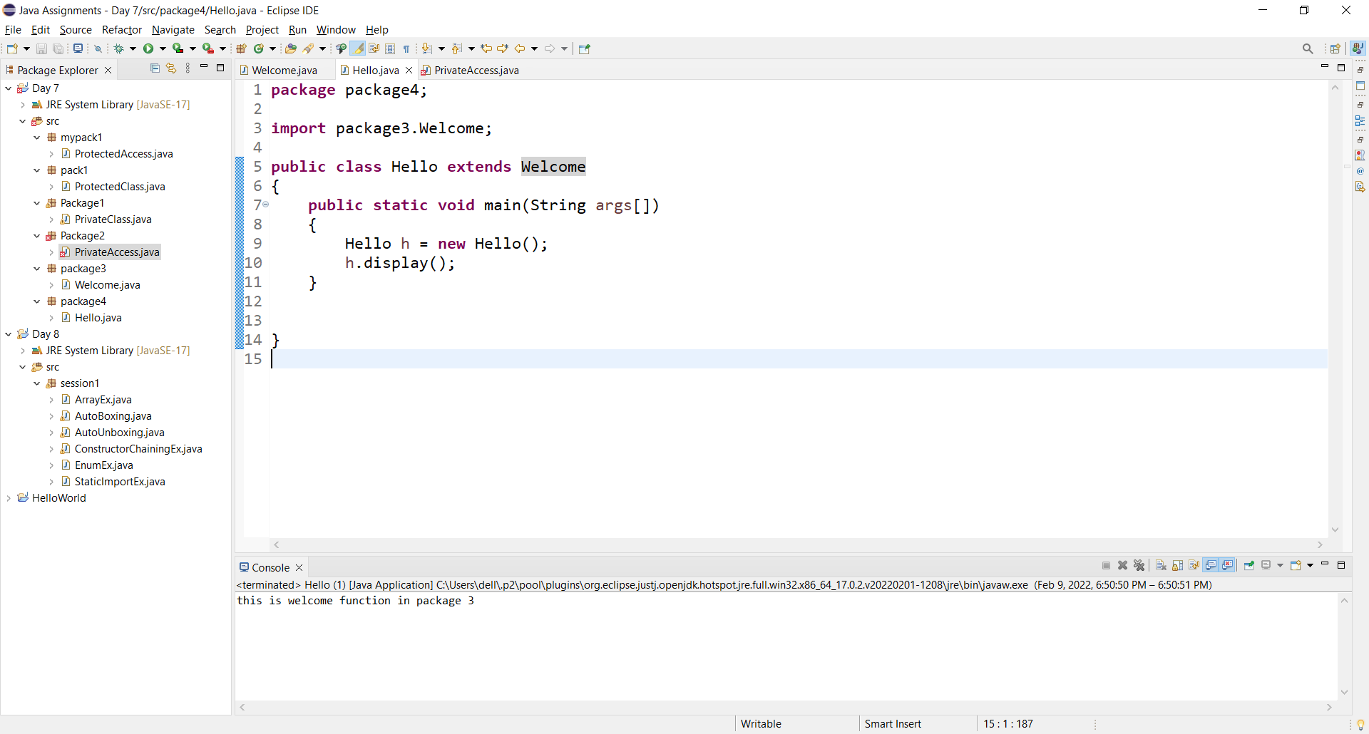

**Public access modifier use in Different package non-subclass:**

Welcome class:



Hello Class:

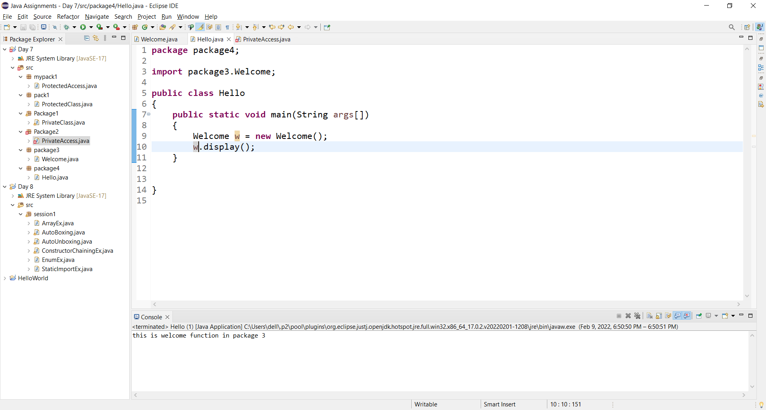

1. Create a PrivateAccess class, private data members when we are trying to call the private data member and method of a PrivateClass class it gives us a compile-time error because private data members and methods have an access level to PrivateClass class only.

PrivateClass class in package1:

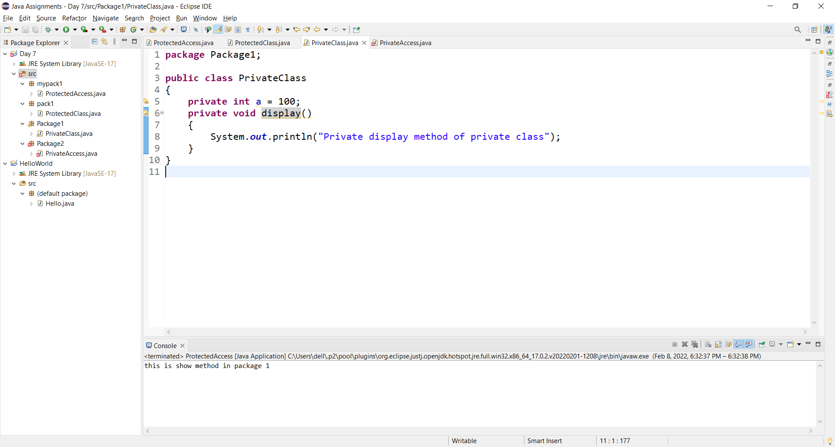

PrivateAccess class in package2:

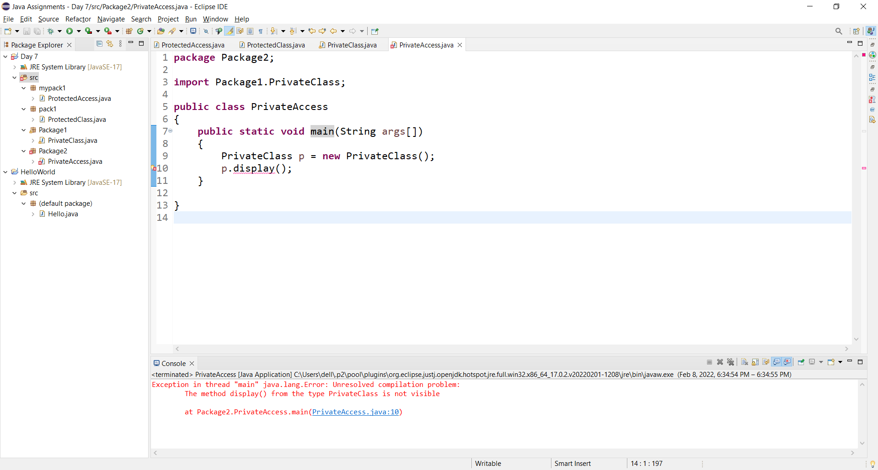

1. Create a class ProtectedClass under a package pack1 in which we declare a protected method show(), create a class ProtectedAccess under a package mypack1 and import a package pack1.

ProtectedClass class:

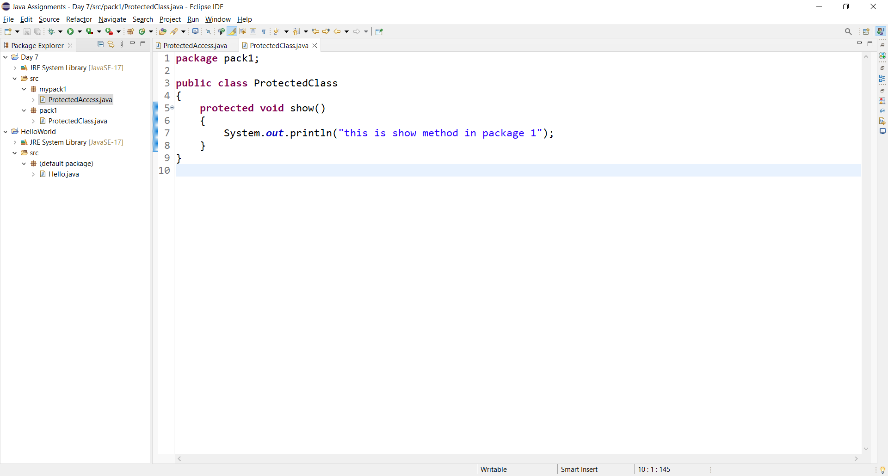

ProtectedAccess class:

